Ref – Mittal P. Cranial keyhole defect from a non-tangential bullet strike – an exploration of additional mechanism, enlightened with a case report and literature review. Anil Aggrawal's Internet Journal of Forensic Medicine and Toxicology [serial online], 2021; Vol. 22, No. 2 (July - December 2021): [about 29 p]. Available from: http://anilaggrawal.com/ij/vol_022_no_002/papers/paper003.html. Published as Epub Ahead: Mar 9, 2021.

Access the journal at - http://anilaggrawal.com

**********************************

Cranial keyhole defect from a non-tangential bullet strike – an exploration of additional mechanism, enlightened with a case report and literature review

By
Pawan Mittal,
Department of Forensic Medicine,
B.P.S. Government Medical College for Women,
Khanpur Kalan, Sonipat, Haryana,
India
Correspondence at:
Pawan Mittal
Residence: Sector-35, Suncity Township, Rohtak, Haryana
Contact No. +91-9991986390
E-mail Address: drmittalpawan@gmail.com

ABSTRACT
The keyhole lesion has been classically related to a tangential and superficial bullet strike to the cranium. A case of homicidal perforating gunshot wound to the head is described that showed an entrance keyhole defect over the left parietal bone while the corresponding exit defect was present over the ipsilateral sphenoid region. The lesion comprised of a roundish defect with internal beveling and a wedge-semicircular defect with external beveling that upon first inspection was present as a partly detached bone plug under the scalp and easily movable in a hinge-like manner. An autopsy reconstruction of the bullet track suggested an atypical and non-tangential strike over the cranium, causing through and through perforation of brain. An intact full metal jacket bullet was recovered from the scene. The traditional explanation of the keyhole lesion following a tangential strike has sometimes created difficulties in wound interpretation in the past. In the present case, the possible mode of the keyhole formation from a non-tangential strike is explained that may help the pathologist in ascertaining the shot direction, in case confusion arises during the autopsy. An appropriate observation can further help in avoiding a legal bearing that may possibly arise in the future.
Keywords: forensic ballistic; skull fracture; wounds; gunshot

- Introduction
The creation of a bone ballistic wound is a complex phenomenon that results from the action of a missile and the reaction of the bone tissue.¹ The most relevant feature of a gunshot wound to the cranium is an entrance circular defect with an internal bevel and an external bevel at the exit.² Determining bullet direction is simple when there are entrance and exit defects with appropriate bevels.³ However, there are some atypical gunshot wounds for which determination of the direction of fire is very difficult or impossible.⁴
A keyhole defect is an atypical wound produced by a bullet striking the cranial vault tangentially at a very shallow angle.⁵ The finding has been also reported in long tubular bones such as humerus and femur.^{6,7} The keyhole pattern is usually described in two parts: first, a rounded section with inner table beveling, and second, a triangular section, with outer table beveling.⁸ The rounded part has been attributed to the “entrance” while the triangle part to the “exit”, and they imply that the bullet entered and totally or partially exited the vault in a tangential path.⁹ The defect has been further defined in connection with entry as well as exit wounds.^{1,3,10,11}
The original description of the keyhole defect associates it to a tangential bullet strike in a superficial plane.^{4,5,10,12}
In the present case, a homicidal and perforating gunshot injury to the cranium caused a keyhole entrance defect that was located in a straight and non-tangential path to the bullet track. The finding is described along with the possibly involved mechanism, suiting optimally to its formation.
- Case Details
  - Brief History
The case belongs to a male farmer, 55 years of age, who was brought to the Dep’t of Accident and Emergency after a homicidal gunshot injury over the left side of his head by his brother, on account of some property disputes. Allegedly the deceased was sleeping on his bed in an open varanda with the head in slightly propped up position over pillows. He was fired completely unaware through an open window with a distant shot, by means of a licensed handgun. The bullet struck the top of his head and he became unconscious after little movements and fuss. The accused fled away while the deceased was rushed to the local hospital where he was declared dead on arrival after about 45 minutes. The dead body was sent for postmortem examination.
  - Autopsy Findings
    - External Examination
The case was brought for autopsy in the next day morning, with a postmortem interval of approximately 12 hours. Whole body X-rays ruled out any projectile, particularly in the cranium.
Upon external examination, the body belonged to a well built male person, weighing 90 kg and 179 cm in length. It was clad in white kurta-payjama with smudging of collar and sleeves with dry blood stains. Face and neck were covered with rusty blood clots. Purplish blue post mortem lividity, fixed (slight pallor on sharp pressure) was present over dorsum of the body, sparing typical pressure points. Rigor mortis was well developed all over the body and could not be re-established after breaking. Idiomuscular reaction depicted a persistent and mild surface bulge over right biceps brachii. Scalp was shaven during autopsy.
2.2.2. Injury Details
An oval gunshot entrance wound of 8 mm x 6 mm was present over left parietel scalp region, 6 cm away from the midsagittal axis, just in front of left parietal eminence, 9 cm above left ear helix and 174 cm above left heel. The margins carried a reddish parched abrasion collar of width 2 mm over its medial-superior-inferior margins with tissues prolapsed out through the inferior margin (Figure 1).
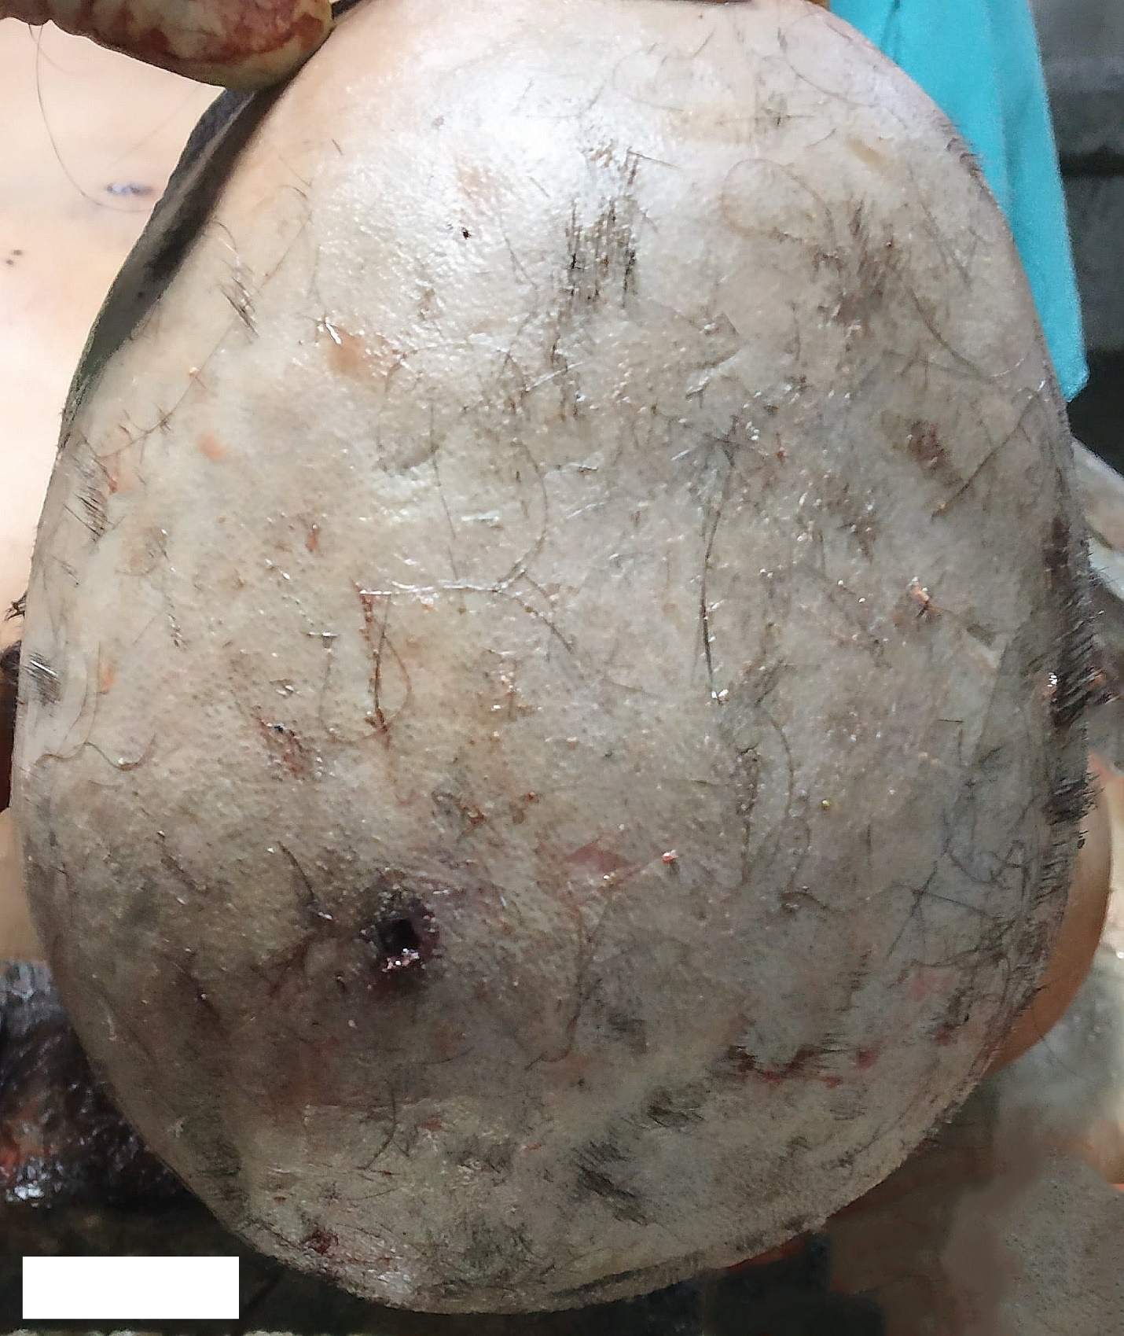
Figure 1: Entrance wound over the left parietal scalp region. Abrasion collar is missing over lateral margin.

No evidence of soot or gunpowder deposit was seen in the scalp hairs or around the wound. Under the scalp wound, a keyhole-shaped skull lesion was observed, showing a roundish defect over right while towards left, a partly squarish to rectangular loosened and slightly uplifted bone plug was present that was divided in two halves by means of a thin fissure fracture passing through its middle thereby enabling hinge-like movement of each half (Figure 2). The overlying periosteum and regional galeal tissues were ecchymosed, detached and torn.
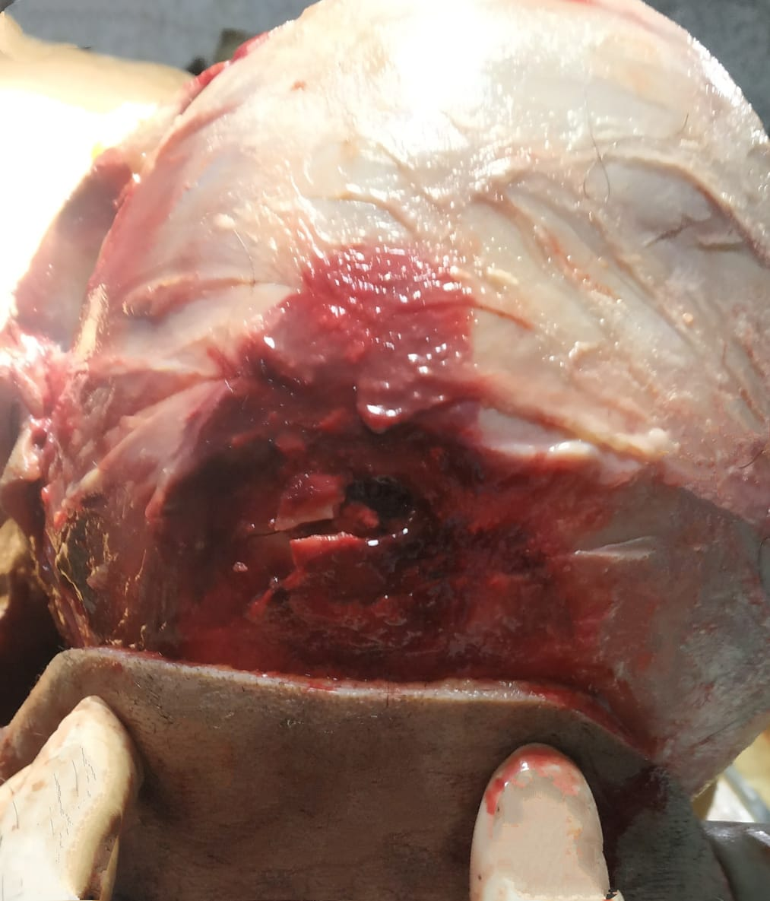
Figure 2: Initial impression of the “keyhole lesion” immediately upon reflection of scalp. A squarish and partly detached- hinged bone plug is visible towards left with the typical round.
defect to the right. The overlying periosteum and regional galeal tissues are hemorrhagic. The periosteum is detached above the lesion.
On removal of the bone plug, the entrance defect took the shape of a complete “keyhole lesion”, with a tiny area of outer bevel just at the end of roundish defect along upper margin while an semicircular externally beveled region was located along the inferior border in continuum with the wedge part of the defect (Figure 3). Corresponding inner beveling of the rounded and adjacent portion of the lesion was present (Figure 4).
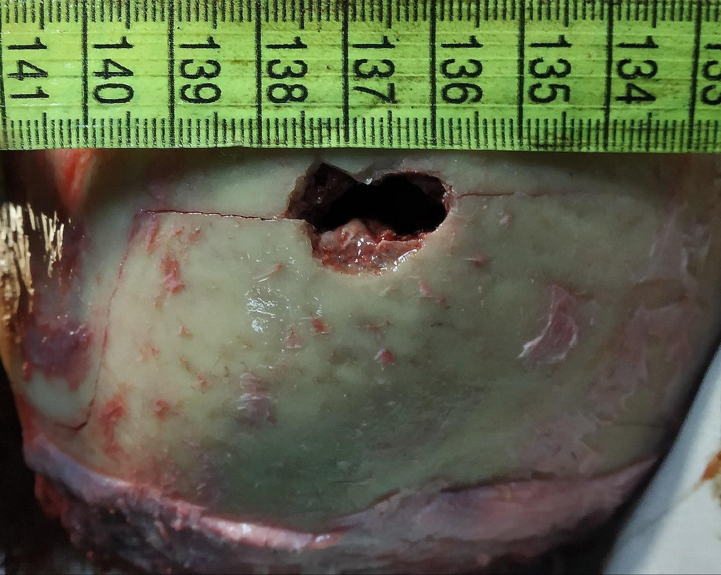
Figure 3: The complete keyhole defect with constituent parts and external beveling. Radiating fractures are extending diagonally from each end.

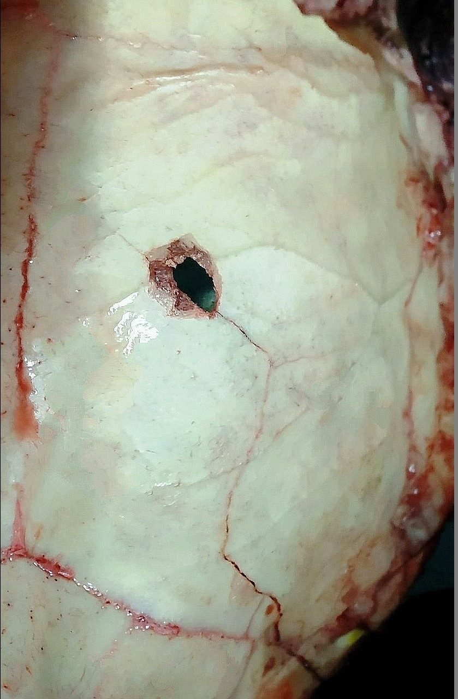
Figure 4: Inner table beveling along with radiating fractures.
Two radiating fractures were extending from the lesion, one from the middle of the roundish portion and coursing towards sagittal suture for a short distance but stopping abruptly before it while the other commenced from the inferior end of the wedge defect, taking a long reverse-Z type course and arrested over the left asterion. The exposed bony trabeculae over the defect showed infiltration of blood. The underlying dura mater was pierced through and through.
The wound further coursed through the left parietal and temporal lobe white matter, taking an almost straight and diagonal course towards left sphenoid bone where a slight horizontally elongated defect of 8 mm x 6 mm with an inferior external beveling was present with soft tissue exit defect situated above it (Figure 5). No inner beveling was present within the exit defect. The exit wound over scalp was free of any abrasion collar.
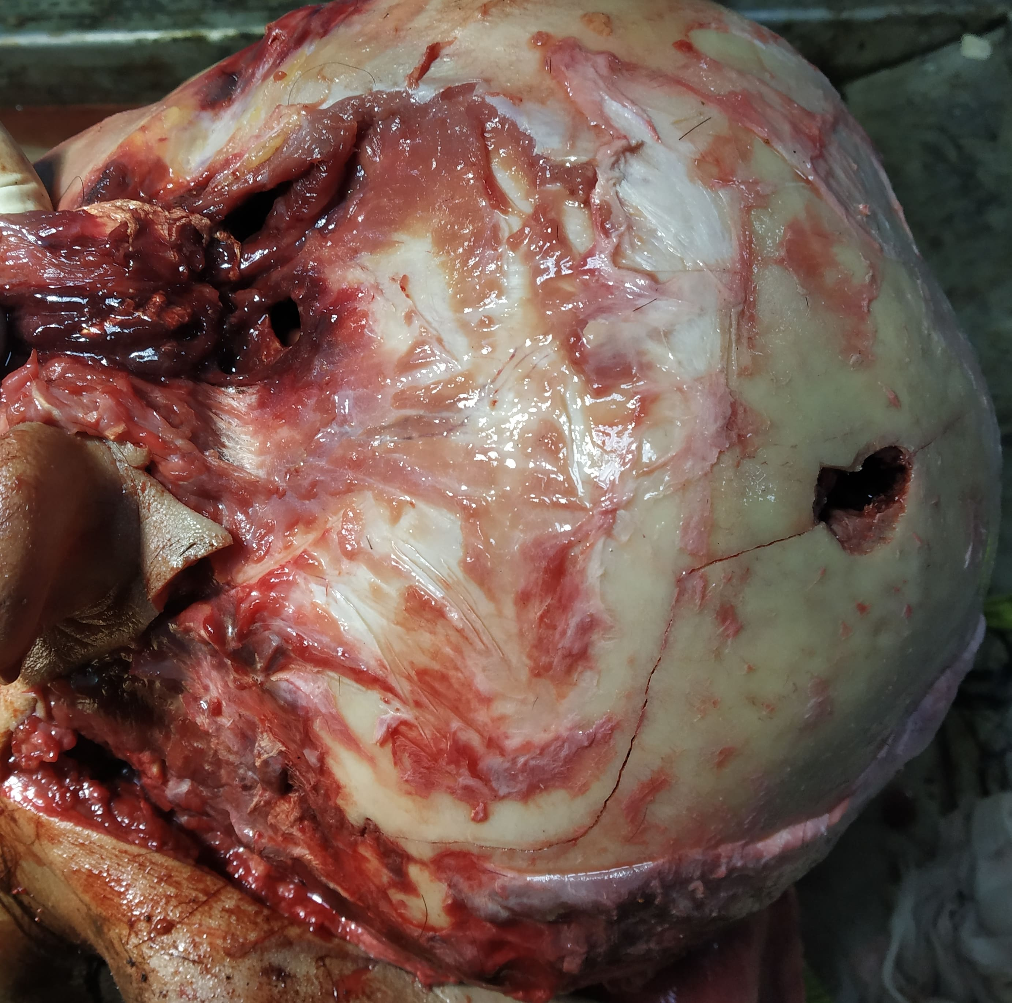
Figure 5: Wound track as seen from external cranium with keyhole entrance defect over left parietal bone while an elliptical exit defect is present over left sphenoid bone with inferior beveling.

A narrow zone of extravasated blood mingled with softened and nectrotic brain matter was present around the crush cavity. Whole of the wound track was hemorrhagic. Diffuse subdural and subarachnoid hemorrhages were present over left frontal-temporal-parietel lobes. Moderate brain swelling was present.
Overall the shot had taken a straight and perforating, non-tangential path from left parietal to sphenoidal region of head with resultant damage to the brain. The passage created an entrance keyhole defect over left parietal bone that was found to be having a partially attached and divided bone plug over wedge area on initial inspection. No evidence of internal ricochet was found at autopsy. No involvement of intermediary target was found. An intact full metal jacket (FMJ) bullet with slightly deformed tip was recovered from the crime scene by the police.
- Discussion
Beveling features in firearm shooting in flat bones have been previously well described.¹³⁻¹⁶ A bullet striking approximately perpendicular to the bones of the vault usually produces a circular entrance wound with internal bevel while during exiting the wound is externally beveled.¹⁷ However not all circular defects with internal bevel are gunshot entrance wounds.³ Cases are on records where cranial circular defects with internal bevel, initially mimicking a gunshot entrance wound were later found to be produced by blunt trauma (due to strike by the umbrella).^{18,19} Similar rare cases of internal beveling due to sharp-blunt trauma have been published in the forensic literature.²⁰
The symmetric or non-symmetric beveling pattern depends on gunshot path and the anatomic features of the bone.²¹ The discovery of atypical findings in the crania involved in gunshot injuries is not uncommon. In this regard, multiple varieties of atypical beveling and wounds have been described, e.g., external bevel over entrance wound,²¹⁻²³ internal bevel in exit wound,²⁴ gutter wounds or gutter defects,²⁵ bone plug over exit defect,²⁶ eccentric or irregular entrance defects,²⁷ and the phenomenon of interrupted beveling^{9,28}. In relation to this, a keyhole defect presents the same variability.⁸
The initial description of the keyhole defect relates it to a peculiar gunshot entrance wound in the cranial vault due to firearm discharge in a tangential and superficial path.^{4,5,10,12} In a typical and classically defined cranial keyhole pattern, the entrance part presents as a rounded defect with inner table beveling and then, with a superficial tangential force, the bullet exits the cranium thereby causing a triangular outer table beveling by chipping.⁸ The overall geometric shape of the wound has been also related to the bullet fragmentation.^{4,9} However, bullet fragmentation is not necessary for the formation of keyhole defect.^{29,30} According to DiMaio, keyhole wound without bullet fragmentation is common with FMJ bullets in which the exit aspect of the keyhole defect is due to pressure waves generated by the impacting bullet lifting and breaking off the bone in a superficial plane.²
Similarly, classic round entrance wounds with external beveling or flaking have been described, resulting from low to medium caliber full jacketed ammunition when fired at different ranges.^{9,21-23} In such cases, the phenomenon of temporary cavitation, gaseous expansion with resulting blowback and the bullet rotation were described as the possible mechanisms but were not related satisfactorily. Furthermore, the full jacketed projectiles frequently pass through the tissues intact, not uncommonly creating round to oval perforating wounds in the cranium.² The presence of a slight external bevel around the roundish part of the lesion in the present case could be ascribed to these mechanisms.
In this regard a possible association of an FMJ bullet to a non-tangential keyhole pattern can be hypothesized. This fact is further supported from a case as well as experimental shots in the study of Delannoy et al where the authors have shown involvement of FMJ bullets in the production of perpendicular keyhole wounds,⁸ although the post-recovery condition of the ammunition was not described. The hypothesis, however, requires further confirmation in similar cases, particularly when relating the type of ammunition to the penetrating and perforating non-tangential keyhole wounds. No projectile was recovered from the cranium in the present case while an intact FMJ bullet was found at the scene.
An increased intracranial pressure on account of temporary cavitation beneath the affected skull segment has been attributed to the outer table beveling by some authors.^{21-23,31} Additionally, the defect can present as either an entrance or exit gunshot wound.^{5,10} In a case of exit keyhole, outer beveling is present around the entire periphery of the defect.¹¹
A frequent observation is relatively larger size of the keyhole wound in comparison to the bullet which is related to the graze effect of the tangential shot than to the perforating effect of the bullet.^{5,12}
Some authors have described keyhole defect as a circular defect in the outer table of skull with internal bevel, usually associated with two divergent radiating fractures.³ The shallow angle, at which the bullet enters, levers a small plate of bone outward leaving an external bevel. In this context, Symes et al have proposed that a concentric heaving fracture is often formed between the two radiating fractures thereby creating an outward levering and spalling of bone, producing an external bevel at the point of “most resistance”.³² Thereafter, the entrance oval defect along with the spalled bone region resembles an old-fashioned keyhole.^{3,5,32,33}
Delannoy et al have described the formation of keyhole lesion from a perpendicular shot to the cranium.⁸ Their case belonged to a man with two suicidal gunshot injuries over head, inflicted from different firearm weapons. The entrance wound over right temporal skull region depicted typical keyhole defect as a part of perpendicular bullet track, furthered with an incomplete subcutaneous exit over contra lateral temporal region. The authors additionally verified the results through an experimental study involving 12 human cadaveric crania fired in a perpendicular plane and successfully produced the keyhole defect in one of them. A micro-CT analysis of the defect lead them to conclude that the production of keyhole defect can be additionally explained by the formation of secondary and tertiary fractures on account of ballistic trauma irrespective of the angle of bullet strike, i.e., in tangential as well as in perpendicular mode.⁸
Berryman and Gunther, in their case of gunshot keyhole defect in humerus bone had hypothesized that the secondary linear fractures radiating away from primary impact point of the bullet were associated with arc like tertiary concentric fractures located further away from the initial impact point and placed perpendicular to the radial fracture lines. The fracture complex may further form a web like matrix circumscribing the bullet impact point.⁶
The results obtained in the experimental study of Delannoy et al involving micro-CT analysis in addition further provided a more advanced and detailed view of the findings.⁸ Their study provided an additional support to the theory of Berryman and Gunther.^{6,8}
From the biomechanical point of view, the formation of keyhole defect in the present case can be explained with this fracture mechanism complex. Furthermore the square shaped plug of the keyhole lesion, with its component segments (Figure 2), is a sufficient finding reflective of secondary and tertiary fracture formation as the possible mechanism for non-tangential strikes. The finding further corroborates well to the proposed theory of Delannoy et al, i.e., perpendicular bullet strike to the cranium with keyhole lesion.⁸
The mechanism complex of primary-secondary-tertiary fractures in relation to ballistic and blunt trauma is well known in forensic literature.^{32,35}
Hart examined the beveling direction of concentric fractures in the skulls of blunt force as well as ballistics trauma in order to differentiate the trauma mechanisms. Their investigation comprised a total of 163 blunt and ballistic impacts in 120 skulls. The hypothesis of the study was that blunt force and ballistics trauma can be differentiated by the pattern of beveling in concentric fractures.³⁵ On the basis of the fact that the bone breaks in a direction from tension to compression,^{33,36} Hart showed that for blunt impacts peripheral tension break at the outer table first, with fracture propagation to the inner table of the vault, causing an internal beveling over concentric fractures.³⁵ For ballistic impacts, the peripheral tension around the impact point breaks the inner table first (due to increased intra cranial pressure), and the fracture propagates towards the outer table of vault. These concentric fractures then demonstrated external beveling. The study concluded that cranial concentric fractures associated with blunt force trauma are internally beveled, whereas concentric fractures resulting from ballistics trauma are externally beveled.³⁵ Similarly the concentric fractures of exit wounds are also externally beveled.^{35,37}
Considering the study details of Hart and Berryman and Gunther, Delannoy et al described the keyhole formation in a tangential as well as perpendicular bullet placement with the following lines:^{6,8,35} the bullet first impacts the bone causing extension of radial fractures from the impact point (the usual roundish part). Thereafter, concentric fractures are created far from the initial impact point, with outer table beveling. Now, in case of a perpendicular shot, the concentric fracture beveling produces a triangular to wedge shaped detached bone plug that does not chip away but is movable under the effect of fracture lines while in a case of tangential shot the outer table beveling is associated with a chipping mechanism which is created by the bullet as it sweeps underneath the bone.⁹ This chipping causes expulsion and sometimes even fragmentation of the triangular part of the lesion, which is not in case of perpendicular strikes that causes only “detachment” of the triangular portion which is movable under the effect of fracture lines.⁹
In the present case, the partly detached bone plug over squared area strongly favors the possibility of the above described mechanism in a non-tangential strike. The plug was further fragmented in two halves from the middle, and freely movable subcutaneously. This may be on account of slight asymmetry and one sided location of the bullet track, in comparison to a perpendicular-symmetrical path proposed by Delannoy et al.⁸ However no mentions were made regarding retrieval of a similar detached bone segment or plug in the case of Delannoy et al.⁸ Similar bone plugs have been described by forensic pathologists as well as in archeological contexts in relation to low velocity projectile trauma causing incomplete exits.^{2,26,38,39}
The singular association between the tangential bullet trajectory and keyhole pattern has been confusing and refuted several times. The cases involving these situations represented non-tangential gunshot paths in the presence of keyhole defects.^{4,10} The observations and analysis of Berryman and Gunther, Hart and Delannoy et al can be appropriately used in explaining the possibility of keyhole defect in non-tangential and perpendicular bullet impacts.^{6,8,35}
In the author’s knowledge, this is a second case study (after Delannoy et al⁸) showing the phenomenon of cranial keyhole defect from a non-tangential bullet strike followed by a deep perforating bullet path while an in-situ presence of the bone plug has not been previously reported in this lesion. The bony plug or chip formation with its retention is probably the necessary prerequisite in non-tangential strikes, considering its mechanism of formation.
Furthermore, such bone plugs may be easily overlooked from a non-professional and hurried approach towards autopsy. Every gunshot case mandates a careful and sensible postmortem examination on account of atypical and unforeseeable findings that may be encountered. Such findings may prove to be the sole factor in the final revelations that may carry a significant legal bearing on the case.
The direction of the shot as alleged by the witnesses and the police in this case could be positively attested, despite the presence of a keyhole defect in a non-tangential bullet path.
It is further added that a combined result of intrinsic and extrinsic factors along with bone specificities is the chief determinant in the production of gunshot wounds.³ So a prior anticipation of skull wounds in cases carrying similar circumstances is not possible due to remarkable inter-individual variations. This fact is further supported from the experimental study of Delannoy et al in which, out of the 12 cadaveric skulls each fired perpendicularly with a 9 mm parabellum ammunition, only one case depicted the specific keyhole lesion in question.⁸
Presently, it is also not possible to explain the exact site of external beveling in a keyhole entrance defect resulting from a non-tangential cranial strike, as the same does not seem to relate perfectly with the angle of bullet strike. The difficulty of relating beveling symmetry with the angle of bullet strike has been also previously reported.^{13,16} Although most of authors do not agree upon this.³² In this regard, the possible variations in skull’s morphological characteristics such as local thickness and curvatures as well as its visco-elastic and anisotropic characteristics cannot be overemphasized.^{32,33}
An additional finding worth consideration in the present case was the torn and hemorrhagic periosteum and adjoining galeal tissues around the lesion. This finding has been attributed to the effects of radial stretching, temporary cavitation and gasous expansion beneath the periosteum thereby loosening and tearing it (viz. Periosteal sign).⁴⁰ In the present case, an attribution to the periosteal injury by the fragmented bone plug cannot be possibly ruled out.
- Conclusion
The old explanation of tangential gunshot path has been complicated and refuted by finding non-tangential strikes with entrance and exit keyholes. The mechanism of keyhole injury is indeed complex, that can be possibly explained in many ways but it is the progression mode of fracture from primary bullet impact through secondary and tertiary/concentric fractures along with appropriate bevels that can suitably explain this phenomenon in tangential as well as non-tangential or perpendicular bullet strikes. In this regard, the physical parameters of the ammunition particularly the caliber, velocity and jacketing properties, along with fracture characteristics and the intrinsic bone properties require adjudication to ascertain the facts leading to such atypical findings.³ An exhaustive detail of circumstances in such cases carries paramount importance. The triad of intersecting fractures may explain the formation of keyhole pattern over cranium, irrespective of the direction of projectile strike.
References
  - Martrille L, Symes SA. Interpretation of long bones ballistic trauma. Forensic Sci Int. 2019 Sep;302:109890. doi: 10.1016/j.forsciint.2019.109890. Epub 2019 Jul 30. PMID: 31421439.
  - Di Maio VJM. Gunshot wounds: practical aspects of firearms, ballistics and forensic techniques. 3rd ed. Boca Raton: CRC Press; 2016.
  - Berryman HE. A systematic approach to the interpretation of gunshot wound trauma to the cranium. Forensic Sci Int. 2019 Aug;301:306-317. doi: 10.1016/j.forsciint.2019.05.019. Epub 2019 May 17. PMID: 31207550.
  - Kobayashi M, Sakurada K, Nakajima M, Iwase H, Hatanaka K, Matsuda Y, Ikegaya H, Takatori T. A 'keyhole lesion' gunshot wound in an adipocere case. Leg Med (Tokyo). 1999 Sep;1(3):170-3. doi: 10.1016/s1344-6223(99)80031-5. PMID: 12935489.
  - Dixon DS. Keyhole lesions in gunshot wounds of the skull and direction of fire. J Forensic Sci. 1982 Jul;27(3):555-66. doi: 10.1520/JFS12168J. PMID: 7119712.
  - Berryman HE, Gunther WM. Keyhole defect production in tubular bone. J Forensic Sci. 2000 Mar;45(2):483-7. doi: 10.1520/JFS14712J. PMID: 10782979.
  - Baraybar JP, Gasior M. Forensic anthropology and the most probable cause of death in cases of violations against international humanitarian law: an example from Bosnia and Herzegovina. J Forensic Sci. 2006 Jan;51(1):103-8. doi: 10.1111/j.1556-4029.2005.00035.x. PMID: 16423232.
  - Delannoy Y, Colard T, Le Garff E, Humez S, Gosset D, Hedouin V. The mechanism of the keyhole lesion reassessed: An experimental approach. J Forensic Leg Med. 2016 Jan;37:1-7. doi: 10.1016/j.jflm.2015.09.020. Epub 2015 Oct 9. PMID: 26497111.
  - Spitz WU. Injury by gunfire: gunshot wounds. In: Spitz WU, editors. Spitz and Fisher's medicolegal investigation of death: guidelines for the application of pathology to crime investigation. 4th ed. Springfield IL: Charles C Thomas; 2006. p. 607-705.
  - Dixon DS. Exit keyhole lesion and direction of fire in a gunshot wound of the skull. J Forensic Sci. 1984 Jan;29(1):336-9. doi: 10.1520/JFS11670J. PMID: 6699601.
  - İscan MY, Steyn M. The human skeleton in forensic medicine. 1st ed. Springfield IL: Charles C Thomas; 2006.
  - Harada K, Kuroda R, Nakajima M, Takizawa A, Yoshida K. An autopsy case of a decomposed body with keyhole gunshot wound and secondary skull fractures. Leg Med (Tokyo). 2012 Sep;14(5):255-7. doi: 10.1016/j.legalmed.2012.04.005. Epub 2012 May 24. PMID: 22633563.
  - Quatrehomme G, Işcan MY. Analysis of beveling in gunshot entrance wounds. Forensic Sci Int. 1998 Apr 22;93(1):45-60. doi: 10.1016/s0379-0738(98)00030-9. PMID: 9618910.
  - Quatrehomme G, Işcan MY. Gunshot wounds to the skull: comparison of entries and exits. Forensic Sci Int. 1998 Jun 8;94(1-2):141-6. doi: 10.1016/s0379-0738(98)00056-5. PMID: 9670492.
  - Quatrehomme G, Işcan MY. Characteristics of gunshot wounds in the skull. J Forensic Sci. 1999 May;44(3):568-76. doi: 10.1520/JFS14511J. PMID: 10408112.
  - Quatrehomme G, Işcan MY. Bevelling in exit gunshot wounds in bones. Forensic Sci Int. 1997 Sep 19;89(1-2):93-101. doi: 10.1016/s0379-0738(97)00121-7. PMID: 9306668.
  - Smith OC, Berryman HE, Lahren CH. Cranial fracture patterns and estimate of direction from low velocity gunshot wounds. J Forensic Sci. 1987 Sep;32(5):1416-21. doi: 10.1520/JFS11188J. PMID: 3668481.
  - Spatola BF. Atypical gunshot and blunt force injuries: wounds along the biomechanical continuum. In: Passalacqua NV, Rainwater CW, editors. Skeletal Trauma Analysis: Case Studies in Context. 1st ed. Hoboken NJ: John Wiley & Sons Ltd; 2015. p. 7–26.
  - Quatrehomme G, Piercecchi-Marti MD, Buchet L, Alunni V. Bone beveling caused by blunt trauma: a case report. Int J Legal Med. 2016 May;130(3):771-5. doi: 10.1007/s00414-015-1293-0. Epub 2015 Nov 19. PMID: 26585737.
  - Delannoy Y, Colard T, Becart A, Tournel G, Gosset D, Hedouin V. Typical external skull beveling wound unlinked with a gunshot. Forensic Sci Int. 2013 Mar 10;226(1-3):e4-8. doi: 10.1016/j.forsciint.2012.12.001. Epub 2012 Dec 23. PMID: 23266305.
  - Baik SO, Uku JM, Sikirica M. A case of external beveling with an entrance gunshot wound to the skull made by a small caliber rifle bullet. Am J Forensic Med Pathol. 1991 Dec;12(4):334-6. doi: 10.1097/00000433-199112000-00012. PMID: 1807145.
  - Coe JI. External beveling of entrance wounds by handguns. Am J Forensic Med Pathol. 1982 Sep;3(3):215-9. doi: 10.1097/00000433-198209000-00006. PMID: 7148775.
  - Peterson BL. External beveling of cranial gunshot entrance wounds. J Forensic Sci. 1991 Sep;36(5):1592-5. doi: 10.1520/JFS13181J. PMID: 1955845.
  - Bhoopat T. A case of internal beveling with an exit gunshot wound to the skull. Forensic Sci Int. 1995 Jan 30;71(2):97-101. doi: 10.1016/0379-0738(94)01644-k. PMID: 7868013.
  - Cushing H. Notes on penetrating wounds of the brain. Br Med J. 1918 Feb 23;1(2982):221-6. doi: 10.1136/bmj.1.2982.221. PMID: 20768944; PMCID: PMC2340105.
  - Bird CE, Fleischman JM. A rare case of an intact bone plug associated with a gunshot exit wound. J Forensic Sci. 2015 Jul;60(4):1074-7. doi: 10.1111/1556-4029.12756. Epub 2015 Apr 2. PMID: 25832722.
  - Kimmerle EH, Baraybar JP. Skeletal Trauma: Identification of Injuries Resulting from Human Rights Abuse and Armed Conflict. 1st ed. Boca Raton: CRC Press Taylor & Francis Group; 2008.
  - Madea B, Staak M. Determination of the sequence of gunshot wounds of the skull. J Forensic Sci Soc. 1988 Sep-Dec;28(5-6):321-8. doi: 10.1016/s0015-7368(88)72858-3. PMID: 3068330.
  - Thali MJ, Kneubuehl B, Vock P, Allmen Gv, Dirnhofer R. High-speed documented experimental gunshot to a skull-brain model and radiologic virtual autopsy. Am J Forensic Med Pathol. 2002 Sep;23(3):223-8. doi: 10.1097/00000433-200209000-00003. PMID: 12198345.
  - Thali MJ, Kneubuehl BP, Zollinger U, Dirnhofer R. A study of the morphology of gunshot entrance wounds, in connection with their dynamic creation, utilizing the "skin-skull-brain model". Forensic Sci Int. 2002 Feb 18;125(2-3):190-4. doi: 10.1016/s0379-0738(01)00638-7. PMID: 11909662.
  - Davis GJ. An atypical shotgun entrance wound caused by a sabot slug. All is not as it seems. Am J Forensic Med Pathol. 1993 Jun;14(2):162-4. doi: 10.1097/00000433-199306000-00013. PMID: 8328440.
  - Symes SA, L’Abbé EN, Chapman EN, Wolff I, Dirkmaat DC. Interpreting traumatic injury to bone in medicolegal investigations. In: Dirkmaat DC, editor. A companion to forensic anthropology. 1st ed. Chichester: Wiley-Blackwell; 2012. p. 340–89.
  - Berryman HE, Symes SA. Recognizing gunshot trauma and blunt cranial trauma through fracture interpretation. In: Reichs KJ, editors. Forensic osteology: advances in the identification of human remains. 2nd ed. Springfield IL: Charles C Thomas; 1998. p. 333–52.
  - Gurdjian ES, Webster JE, Lissner HR. The mechanism of skull fracture. Radiology. 1950 Mar;54(3):313-39. doi: 10.1148/54.3.313. PMID: 15406455.
  - Hart GO. Fracture pattern interpretation in the skull: differentiating blunt force from ballistics trauma using concentric fractures. J Forensic Sci. 2005 Nov;50(6):1276-81. doi: 10.1520/JFS2004219. PMID: 16382818.
  - Galloway A, Wedel VL. Fracture patterns and skeletal morphology. In: Galloway A, editor. Broken bones: anthropological analysis of blunt force trauma. 2nd ed. Springfield IL: Charles C Thomas; 1999: p. 133–160.
  - Symes S, Smith O, Berryman H, Peters C, Rochhold L, Haun S, Francisco J, Sutton T, editors. Bones: bullets, burns, bludgeons, blunderers, and why. Bone trauma workshop presented at the 48th annual meeting of the American Academy of Forensic Sciences, Nashville, TN. Proceedings of the American Academy of Forensic Sciences; 1996 Feb:19–24.
  - Murphy MS, Gaither C, Goycochea E, Verano JW, Cock G. Violence and weapon-related trauma at Puruchuco-Huaquerones, Peru. Am J Phys Anthropol. 2010 Aug;142(4):636-49. doi: 10.1002/ajpa.21291. PMID: 20333713.
  - Lew E, Dolinak D, Matshes E. Firearm injuries. In: Dolinak D, Matshes E, Lew E, editors. Forensic pathology: principles and practice. 1st ed. New York: Elsevier Academic Press; 2005: p. 163-200.
  - Faller-Marquardt M, Bohnert M, Pollak S. Detachment of the periosteum and soot staining of its underside in contact shots to the cerebral cranium. Int J Legal Med. 2004 Dec;118(6):343-7. doi: 10.1007/s00414-004-0486-8. Epub 2004 Sep 29. PMID: 15455242.

